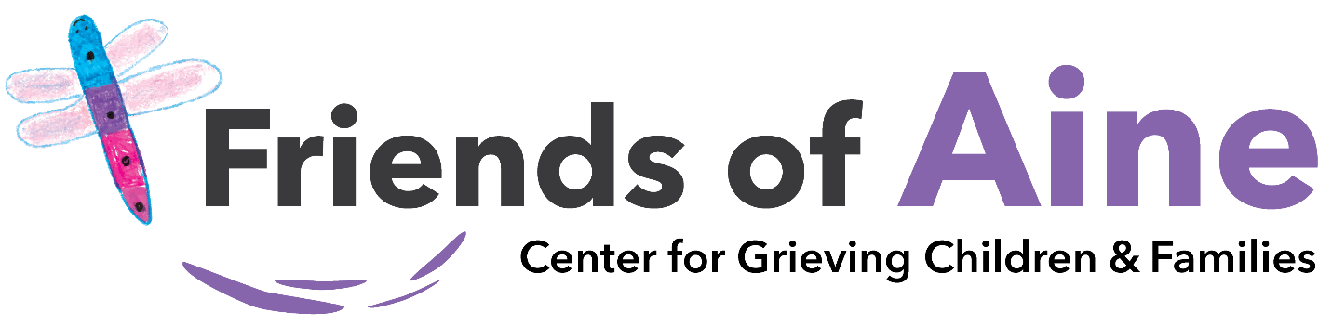

“TALK ABOUT GRIEF” Art Campaign
Calling ALL kids, ages 4-18 years old….do you like to draw, sketch, paint, or doodle? The Friends of Aine Center would like to use your artwork to help grieving children, teens, and families!

1. Illustrate what you do or might do to cope with a difficult situation. What would you do that might make you feel better?
Possible ideas might include: count to 10, take a walk, try something new, take time away from electronics, read, take a nap, yoga, make yourself comfortable, talk to someone, surf, light a candle, care for a plant, go/help plan the funeral/memorial, wear their clothes, bake, visit the cemetery, play games, blow bubbles, volunteer, hug someone, look at photos/videos, sing, watch their favorite movie, journal, play outside, make a wish, laugh, set goals, make plans, cry, eat their favorite food, sit in a quiet place, create a safe space, etc.

2. If someone you love has died, share a drawing, painting, etc. that expresses your feeling. What does your grief look like? How do you feel? Use your art to convey your emotions, communicate, release your grief, or share your story.

Submitting your artwork is easy! Scan the QR code to submit your art.
Questions or comments: Contact jenna06.nh@gmail.com or christine@friendsofaine.com

